1. The first form that opens up in the application is where you will select an applicant by his/her application ID and whether he/she is an In-state applicant or Out-of-state applicant. We are assuming that this information is available to the user of the application.

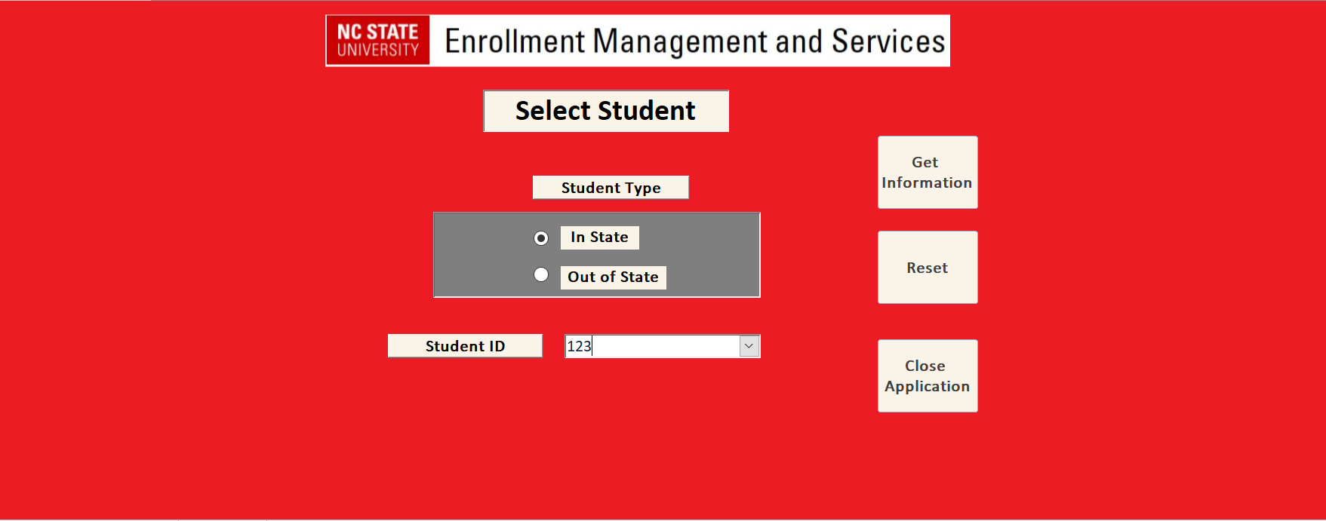

Hit the ‘Get Information’ button to get the information about the applicant.

1. You will see the information as shown below.

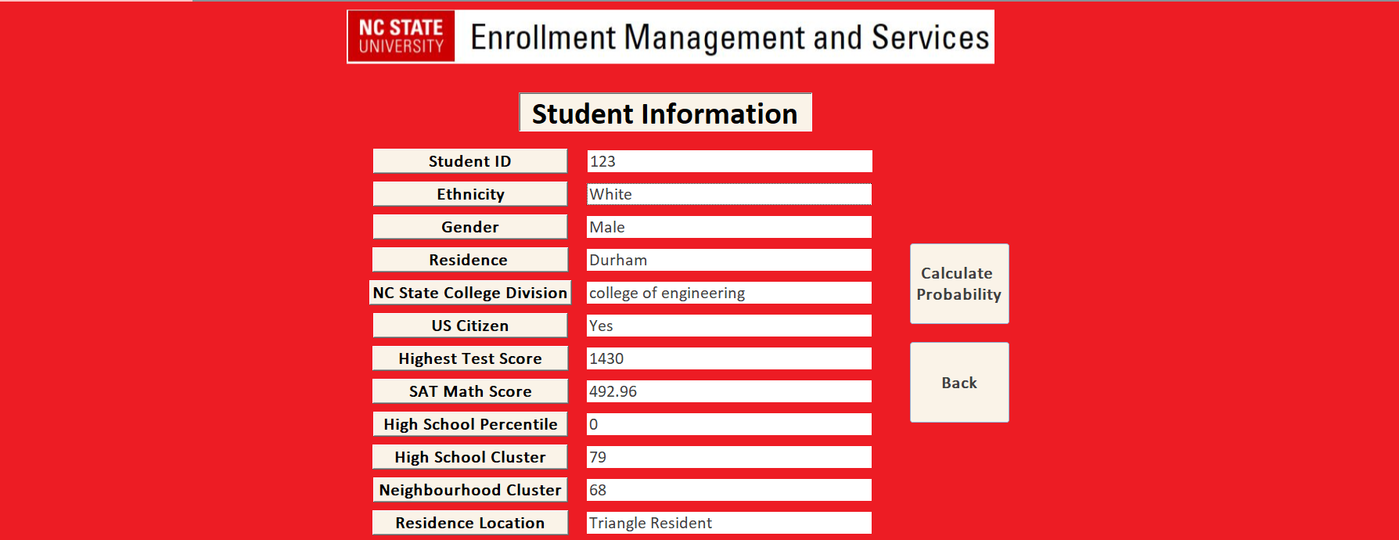

To see how likely the applicant is to enroll if given admission, hit the ‘Calculate Probability’ button.

1. You will see the probability of enrollment along with the same information about the applicant from the previous page.

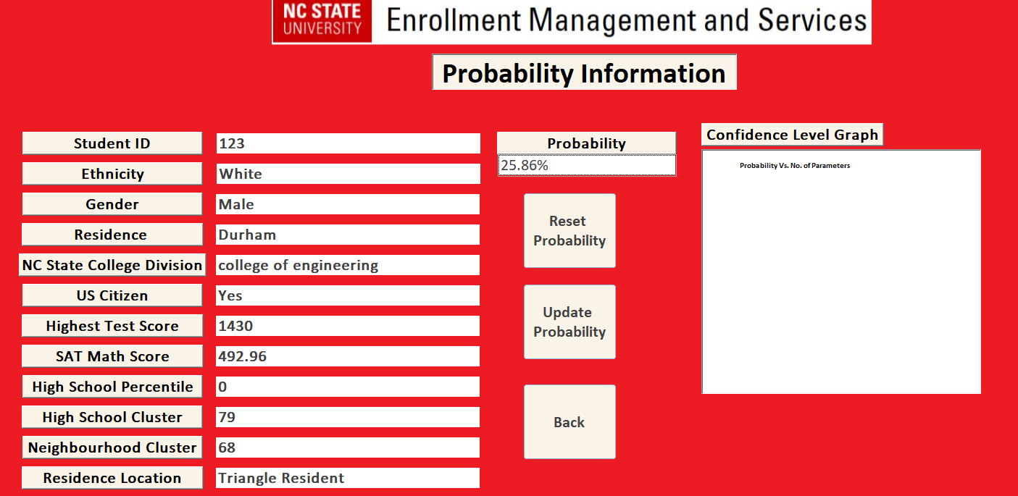

1. Now, if you want to see that what the enrollment probability would be for another applicant having a bit different background, you can do that by selecting ‘Update Probability’. This feature will let you select different values for different attributes and show you what would be the probability in that scenario.

For example, let’s say the applicant is an Asian female with test score 1200. What would be her enrollment probability if given admission?

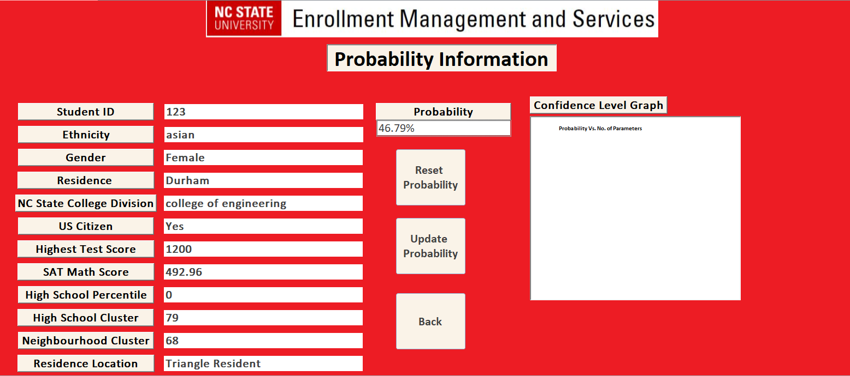

As you see, the probability changed according to the type of applicant we selected.

Below is the list of some of the applicant IDs that you can select to see their information and enrollment probability.

|  |
| --- |
| 117 |
| 120 |
| 123 |
| 156 |
| 159 |
| 162 |
| 171 |
| 180 |
| 183 |
| 195 |
| 222 |
| 225 |
| 270 |
| 273 |
| 276 |
| 279 |
| 282 |
| 285 |
| 303 |
| 309 |
| 312 |
| 315 |
| 330 |
| 333 |
| 342 |
| 345 |
| 357 |
| 360 |
| 414 |
| 417 |
| 453 |
| 456 |
| 474 |
| 477 |
| 696 |
| 699 |
| 726 |
| 729 |
| 756 |
| 759 |
| 813 |
| 816 |
| 819 |
| 822 |
| 885 |
| 894 |
| 897 |
| 900 |
| 939 |
| 942 |
| 945 |
| 948 |
| 1023 |
| 1035 |
| 1038 |
| 1050 |
| 1053 |
| 1056 |
| 1071 |
| 1074 |
| 1077 |
| 1080 |
| 1128 |
| 1206 |
| 1209 |
| 1230 |
| 1233 |
| 1260 |
| 1263 |